**A NOTE ON TIME SERIES WITH SUITABLE EXAMPLES**

STA631 CIA 1 Component 1

Ananya Kaushal

1940233

**INTRODUCTION:**

A time series is a series of [data points](https://en.wikipedia.org/wiki/Data_point) indexed (or listed or graphed) in time order. Time series adds an explicit order dependence between observations: a time dimension. It is a collection of observations obtained through [repeated measurements over time](https://www.influxdata.com/blog/what-is-time-series-data-and-why-should-you-care/). Time series data is everywhere, since time is a constituent of everything that is observable. As our world gets increasingly instrumented, sensors and systems are constantly emitting a relentless stream of [time series data](https://www.influxdata.com/time-series-database/).

Time series are typically assumed to be generated at regularly spaced interval of time (e.g. daily temperature), and so are called regular time series. But the data in a time series doesn’t have to come in regular time intervals. In that case, it is called irregular time series. In irregular time series, the data follows a temporal sequence, but the measurements might not occur at regular time intervals. For example, the data might be generated as a burst or with varying time intervals. Account deposits or withdrawals from an ATM are examples of irregular time series.

Time series can have one or more variables that change over time.  
If there is only one variable varying over time, we call it Univariate time series, e.g. daily temperature. If there is more than one variable it is called Multivariate time series. For example, a tri-axial accelerometer. There are three accelerations variables, one for each axis (*x,y,z*) and they vary simultaneously over time.

Time series data can be useful for:

* Tracking daily, hourly, or weekly weather data
* Tracking changes in application performance
* Medical devices to visualize vitals in real time
* Tracking network logs

Weather records, economic indicators and patient health evolution metrics — all are time series data. Time series data could also be server metrics, application performance monitoring, network data, sensor data, events, clicks and many other types of analytics data.

**TYPES OF TIME SERIES:**

**Linear vs. nonlinear time series data**

A linear time series is one where, for each data point Xt, that data point can be viewed as a linear combination of past or future values or differences. Nonlinear time series are generated by nonlinear dynamic equations. They have features that cannot be modelled by linear processes: time-changing variance, asymmetric cycles, higher-moment structures, thresholds and breaks.

**Deterministic time series**

A deterministic time series is one that can be expressed explicitly by an analytic expression. It has no random or probabilistic aspects. In mathematical terms, it can be described exactly for all time in terms of a Taylor series expansion provided that all its derivatives are known at some arbitrary time. Its past and future are completely specified by the values of these derivatives at that time. If so, then we can always predict its future behaviour and state how it behaved in the past.

**Non-deterministic time series**

A non-deterministic time series is one that cannot be described by an analytic expression. It has some random aspect that prevents its behaviour from being described explicitly. A time series may be non-deterministic because:

1. All the information necessary to describe it explicitly is not available, although it might be in principle.
2. The nature of the generating process is inherently random.

Since non-deterministic time series have a random aspect, it follows probabilistic laws. Thus, the data is defined by statistical terms, i.e. by probability distributions and averages of various forms, such as means and variances.

**Stationary time series**

A stationary time series is one whose statistical properties such as mean, variance, autocorrelation, etc., do not depend upon time. A stationary series is relatively easy to predict: you simply forecast that its statistical properties will be the same in the future as they have been in the past. Thus, most statistical forecasting methods are based on the assumption that the time series are approximately stationary.

Most statistical forecasting methods assume that the series can be rendered (approximately) stationary through mathematical transformations.

## Nonstationary time series

Non-stationary series is one whose statistical properties change over time. There are an infinite number of ways for a time series to be non-stationarity, such as changing variance, level shifts, and seasonality in the 6th moment, etc. Here are the most common non-stationarity patterns:

**Trend component:** The trend shows the general tendency of the data to increase or decrease during a long period of time. A trend is a smooth, general, long-term, average tendency. It is not always necessary that the increase or decrease is in the same direction throughout the given period of time. If a time series does not show an increasing or decreasing pattern then the series is stationary in the mean.

**Cyclical component:** Any pattern showing an up and down movement around a given trend is identified as a cyclical pattern. In a cyclical pattern the up and down movements do not occur in constant time intervals, they cannot be predicted.

**Seasonal component:**If the series peaks and trough occur in regular intervals the pattern is called seasonal pattern (e.g. sales of ice cream).

**Random component:** the residual is what’s leftover when all the patterns have been removed. Residuals are random fluctuations. You can think of them as a noise component.

**TIME SERIES EXAMPLES:**

Example 1: Weather Conditions

Weather conditions like temperature can be recorded in regular time intervals resulting in a time series data. This data is very useful to analyse the weather conditions of a place and is also essential for weather forecasting.

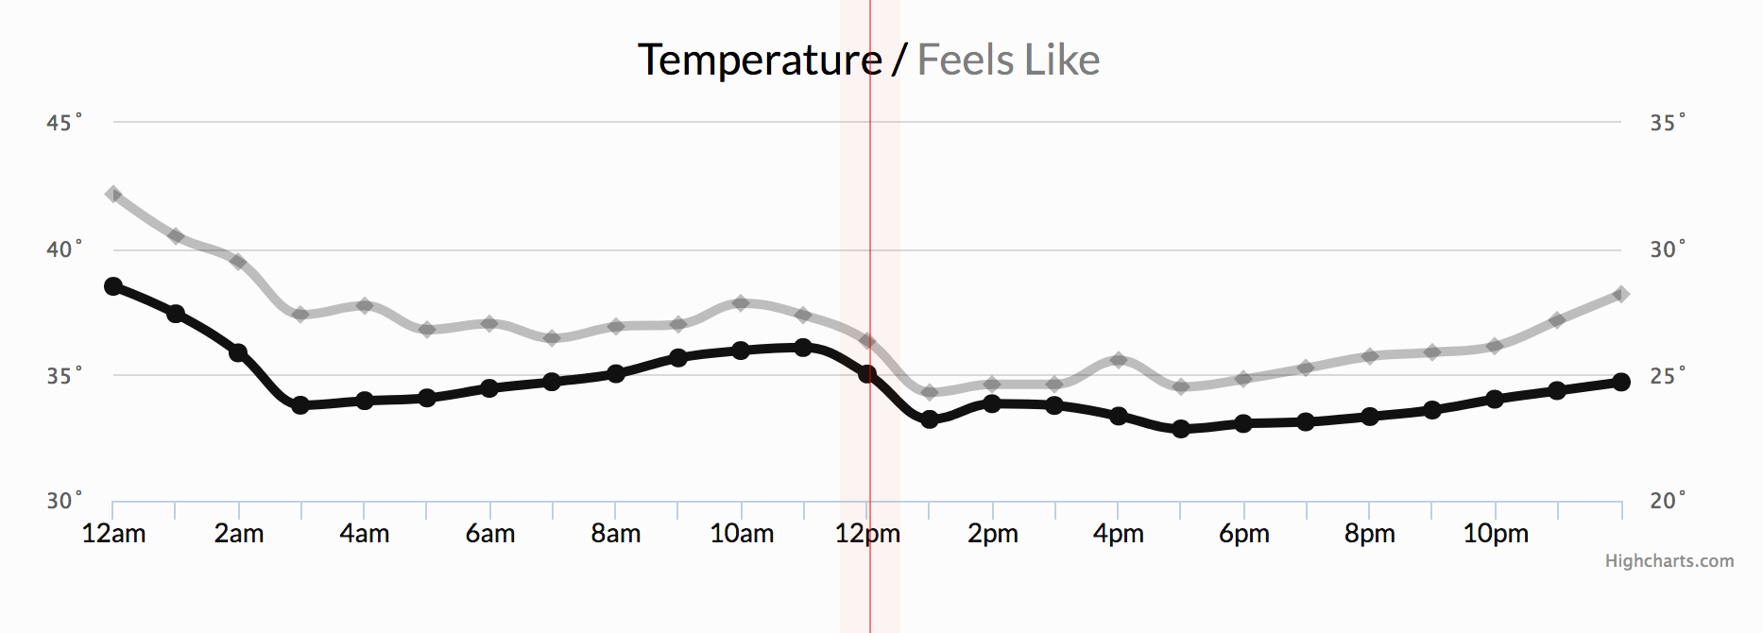

Example 2: Cluster monitoring

The cluster monitoring example below, depicting disk ops write and usage data, would be familiar to Network Operation Centre teams. Monitoring data is time series data.

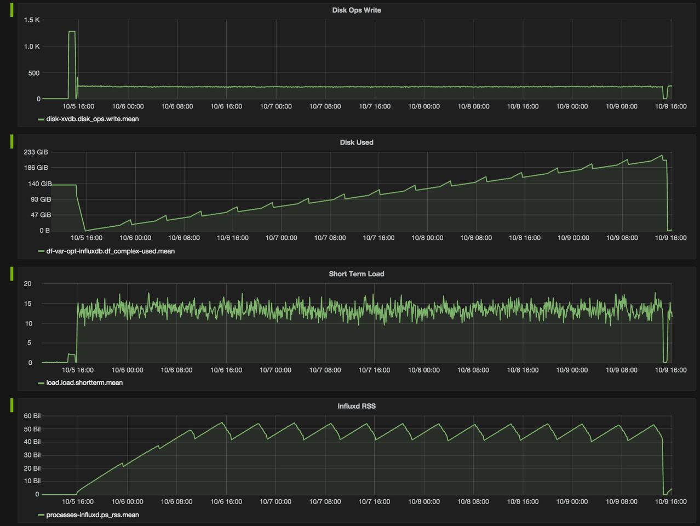

Example 3: Stock exchange

Stock price changes are measured against time. In investing, a time series tracks the movement of data points, such as a security’s price over a specified period of time with data points recorded at regular intervals.

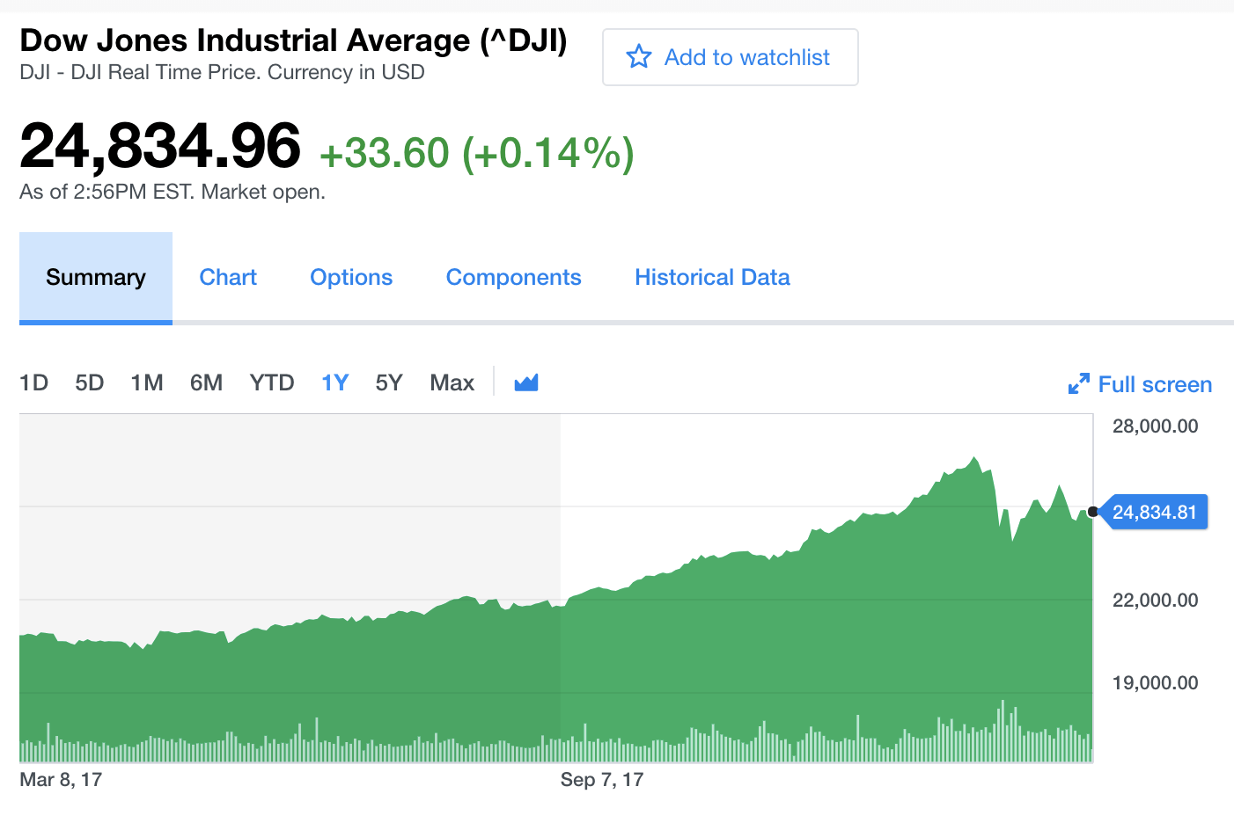

Example 4: Health monitoring

Another familiar example of time series data is patient health monitoring, such as in an electrocardiogram (ECG), which monitors the heart’s activity to show whether it is working normally.

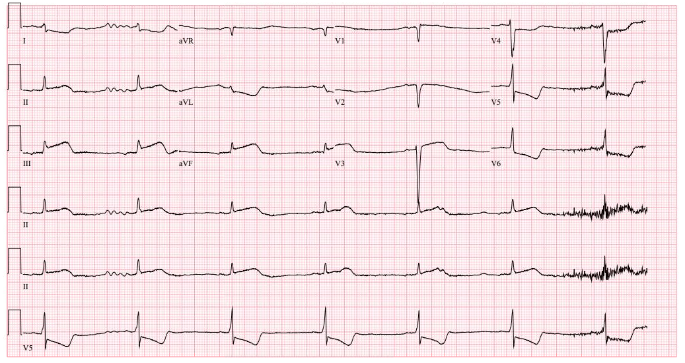

Example 5: Subscribers

Time series analysis is often used by online publications to analyse trends in the total number of subscribers from one year to the next. Time series plots can be particularly useful for identifying whether or not growth in the number of subscribers is increasing, decreasing, or hitting a plateau.

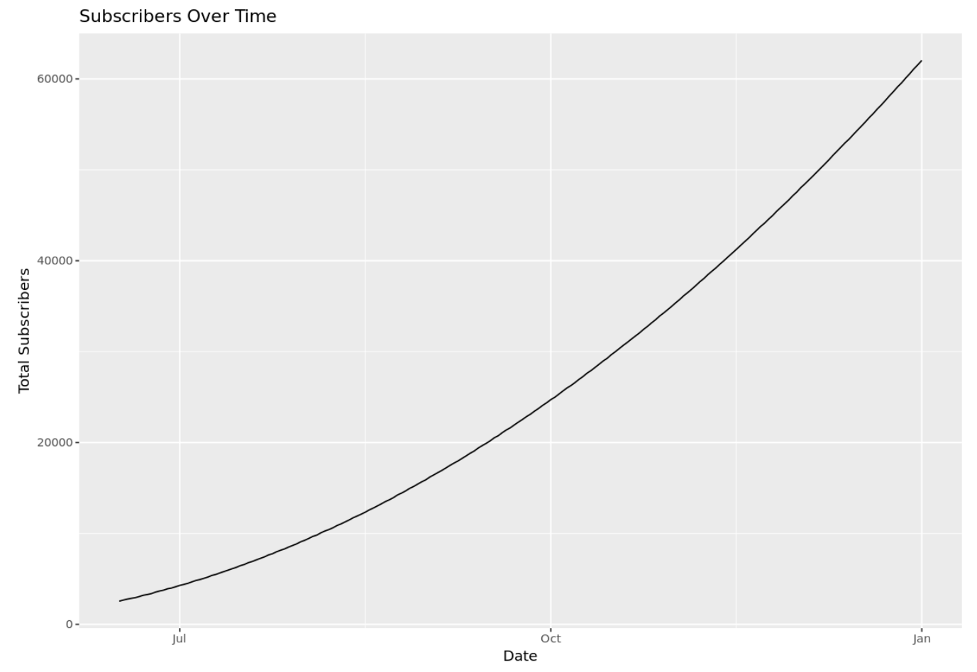

Example 6: Retail Sales

Retail stores often use time series analysis to analyse how their total sales is trending over time. Time series analysis is particularly useful for analysing monthly, seasonal, and yearly trends in sales.

This allows retail stores to be able to more accurately predict what their sales will be during an upcoming period and be able to more accurately predict how much inventory and staff they’ll need during different periods of the year.

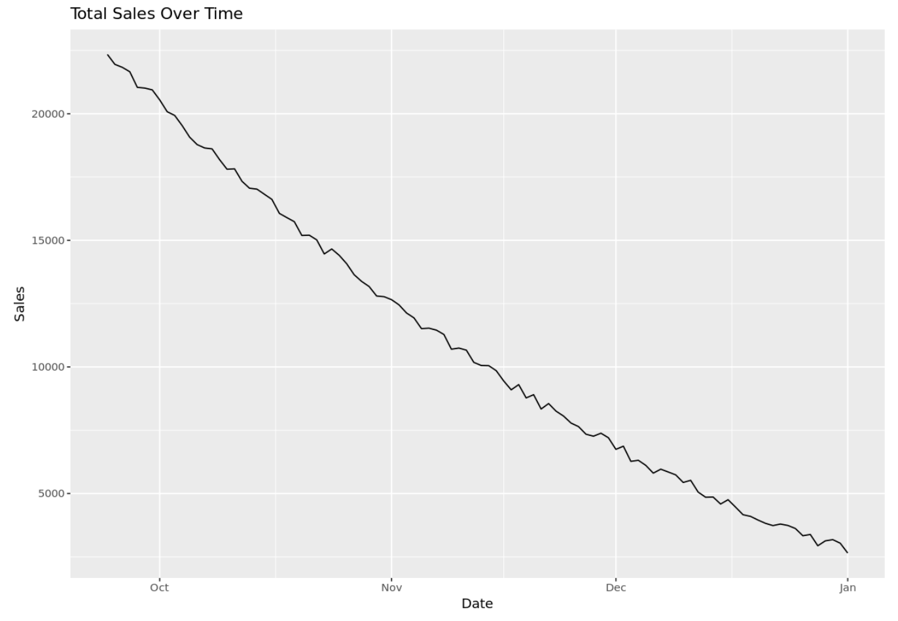

**CONCLUSION:**

In time series analysis, time is a significant variable of the data. Times series analysis helps us study our world and learn how we progress within it. Time series data can be [visualized in different types of charts](https://www.influxdata.com/how-to-visualize-time-series-data/) to facilitate insight extraction, trend analysis, and anomaly detection. Time series data is used in time series analysis (historical or real-time) and time series forecasting to detect and predict patterns, essentially looking at change over time.